



**SM6P07NI Digital Media Project**

**20% Research and Proposal**

**2022-23 Autumn**

**Student Name: Samaya Shrestha**

**London Met ID: 20049329**

**College ID: NP01MM4S210034**

**External Supervisor: Rupesh Dangol**

**Internal Supervisor Dibesh Maskey**

**Assignment Due Date: Wednesday, December 28, 2022**

**Assignment Submission Date: Wednesday, December 28, 2022**

**Word Count: 2302**

*I confirm that I understand my coursework needs to be submitted online via Google Classroom under the relevant module page before the deadline in order for my assignment to be accepted and marked. I am fully aware that late submissions will be treated as non-submission and a marks of zero will be awarded.*

Table of Contents

Abstract 4

Section A: Research 5

1. Introduction 5

2. Literature Review 6

• Game Assets 6

• Textures for Game Assets 7

• Lighting for Game Assets 8

3. Product review 9

Product I: Traditional Nepali House 9

Product II: Traditional Carved Bell 10

Product III: Ghost of Tsushima 11

Product IV: Far Cry 4 12

4. Summary and Conclusion 13

Section B: Project Proposal 14

1. Project Title 14

2. Research Question 15

3. Treatment 16

4. Resources 17

4.1. Software 17

4.2. Hardware 17

4.3. Gantt Chart 17

5. Contribution of Other 18

6. Evaluation & Testing 19

Phase 1: Supervisors Evaluation 19

Phase 2: Third party Evaluation 19

Phase 3: Online Audience Evaluation 19

References 20

Appendix 21

Reference Photos 21

Basantapur Durbar 21

Taleju Bhawani, Kathmandu 22

Newari House Design 23

Design Layout 24

Reference Image Links 25

# Abstract

This project is about making 3D game assets in the context of Nepal. This project will consist of various types of Newari houses and also similar structures of buildings like Basantapur Durbar Square. This documentation will include details of all the research done and proposals for the project.

The documentation is divided into two parts. The first part will include the research part of the project. It will include things like introduction, literature review, product review and conclusion.

Similarly, the section part will contain the proposal part of the project. It will include necessary details of the proposal like title, research question, treatment required resources, etc.

# Section A: Research

## Introduction

Game development is the process of creating, designing, and developing video games. Game development is the long process for which various departments of the development company are required to work on the field of their expertise such as programming, visuals, designs, etc. There are various things which make the game worthwhile for the player. Game Assets are one of those things. They are substances, items that give life to the game and create a worthwhile experience to the players. Game assets include various things like graphics (characters, environments, logos), background music, Special effects, and sound effects.

This project will be an environment, with some architecture that is being made is located in Basantapur. The structures I’ll be making are similar to Basantapur Durbar Square, Kumari Ghar, Taleju temple and some old-style houses from the past.

## Literature Review

### Game Assets

Game development and design is a vast term. For some, it can be considered as anything that goes in the game, whereas, for some, only small parts like emotion engineering or environment engineering can be considered as game development or design. In simple words, game development and design are the process of creating games. This process consists of creating the video game’s concept, gameplay, mechanism, and story with various other aspects like game assets, sound effects, etc.

Game assets can be defined as the visual and auditory elements of the game that contribute to the immersive and entertaining experience of the player. Game assets consist of various things like the environment of the game, characters, objects, and so on. Game development and design with game assets are very important to create a great player experience. While developing and designing a game the creators must consider the assets that are to be used in the game and how they will affect the experience of the game. (Engström, 2020)

Ever since the beginning creators relied on premade assets to use in their games. These assets can be anything from models to sounds which can be used in the games. There are both advantages and disadvantages to using the premade assets in the game. The advantages are it saves money and time, and also gives consistent feels across the game. The disadvantages are it can make the game look similar to others, and assets related to the games may not be found in the market, and no so on. (Martine van den Boomen, 2012)

In the end, game assets come with both advantages and disadvantages. Which has a great significance in the creator’s perception.

### Textures for Game Assets

Texture is one of the most important parts of game assets development. It is the process of giving detail to the models. It is used to make the assets believable and realistic. It can also be used to give the model depth and perspective along with color and materialistic feel to the model. Textures can also give the sensation of touch with the help of sensory visions of the model by making it seem rough and tough or soft and smooth along with making it look aged or new depending on the surface of the model. Due to which the viewers can get more immersed in the experience. In conclusion, texture is very important for asset development as it brings life into a simple lifeless model by giving depth and perspective, color, materialistic feel and so on. (Jones, n.d.)

As written above textures can be used to bring a simple model to life. The textures used can define everything for the model. In this project textures are going to be very essential. As the model are going to contain a small detail, textures are going to be used to give those details to the models. For example, the roof of the traditional houses contains tiles which are going to be made using textures instead of modelling to save time and resource.

### Lighting for Game Assets

Lighting is an important part of asset development. lighting is the combination of techniques that are used for projecting light in a 3D environment to make it look realistic and believable. Lighting is used to relay the emotion of the scene, weather, and time of the day. It also helps the scene by giving highlights, shadows, and adding contrast to the scene. Therefore, it plays a vital role in the rendering process. In conclusion, lighting is important for asset development as it brings the scene to life. The simple manipulation of the light can make the atmosphere and scenario differ, creating the needed psychological effect on the viewer. (Darvideo.tv, n.d.)

The lighting can also define a lot of things for the environment and the scene. The lighting can make a scene or environment go looking from happy and bright to sad and gloomy. In this project the lighting will also play a very important part. The lighting will be used to make the scene or environment bright and sunny. The lights will also be used to highlight the detail of the models.

## Product review

### Product I: Traditional Nepali House

Figure : Traditional House (Shakya, 2021)

This is an old village style house which can be found in various parts of our country. It represents an old village house which was made and stayed for a long time which is made using the texture and some parts are made during modeling. This model is made using simple modeling methods. The main roof is also made of a single part and depth and effects are given using texturing and the edge parts of the roof are separate parts and texturing are used to give effects. In this model the artist has used their texturing skill to give the house a rundown and longtime used look. The artist has used bumps in texturing to give the roof a feel of small tiles even though it’s not. The artist also has given small bumps in the entire project to give the feel of bricks on the wall and the floor.

### Product II: Traditional Carved Bell

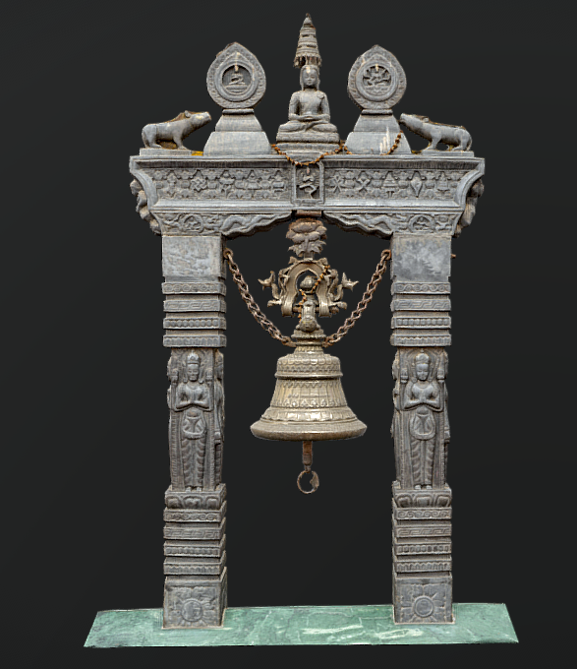

Figure : Traditional Engraved Bell (3Dystopia, 2020)

This is a traditional engraved bell that can be found in various temples of Nepal. In this model there are two parts. The first part of the model is the main bell part which has engraving in it. The second part is the part which is holding the bell in place and has statues on top and engraving on the body. The model is made in a simple modeling manner which has simple loops. The engraving in the part which holds the bells is also modeled which has the shape of a human. And the details on the engraving are made using texturing which includes bumps. Texturing is also used to give the bell a metallic look and give the engraving details using bumps as the part holding the bell. The part holding the bell is given a stone made architecture look using the textures.

### Product III: Ghost of Tsushima

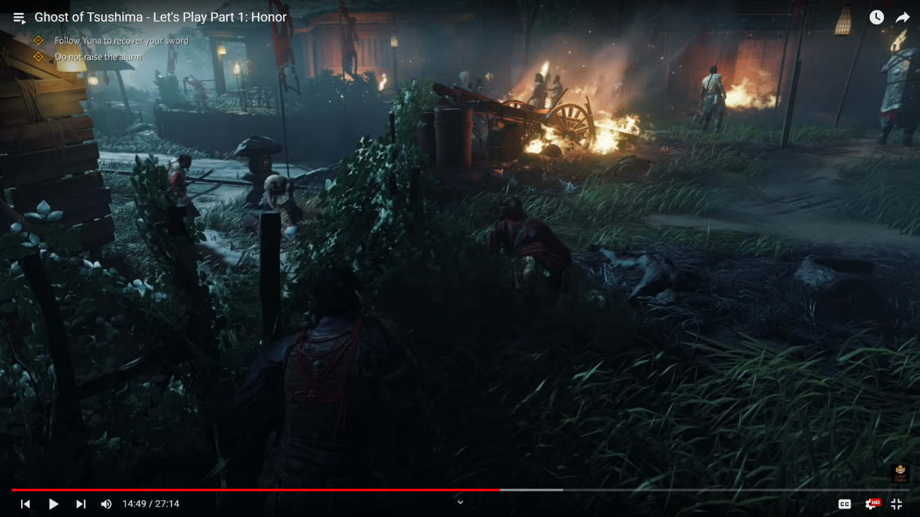

Figure : (FightinCowboy, 2020)

This is a game is base of ancient Japan. This game has is based in the samurai era of Japan. This game is made with precision to detail. The using of lighting and texturing is remarkable. They also have placed various assets all around the game which sets the mood according to the environment. As I said before the remarkable lighting in the game also make an immersive experience for the player. The textures that are used give the feel of touch just by a mare glance at it. The lighting and the texturing combine have given the game depth and detail which cannot go unnoticed.

### Product IV: Far Cry 4

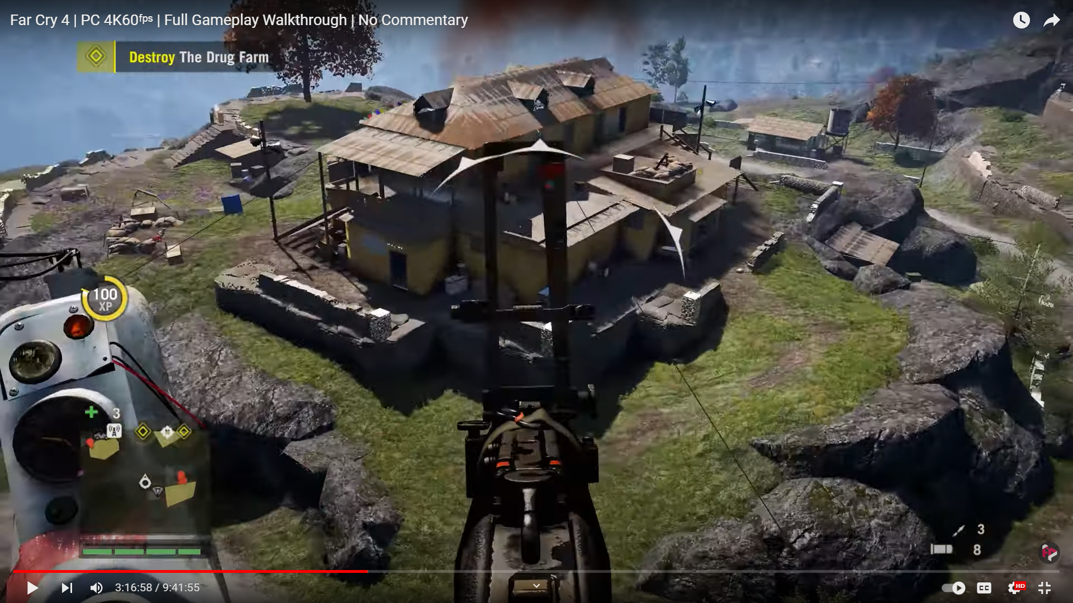

Figure : Far Cry 4 (Walkthrough, 2021)

This game is a first-person shooter and open world game. This game has assets based on Nepal. This game also has good texturing and lighting but lacks a little when it come realism. The assets that are used in the gave are also good. Some of the environmental assets when viewed up come look a little lacking which may ruin the immersive experience for the players. The detail in the game could use a bit more work which may help the game to maintain the immersive experience of the players. The game has used bumps in the texture, but it isn’t proper done. If it was done properly the over game would look more better.

## Summary and Conclusion

Creation of 3D assets is one of the important and popular trends among the game developers. Even though there are all kinds of assets that you can find on the internet, there never seems to be enough. Due to which, the aim of this project is to create assets which can be used in all kinds of game, specially which are based in the Nepali culture. The structures which are being created won’t be the same but similar kinds of architecture can be found in the country and its history.

By using various combinations of 3D modeling and texturing, this project will be aiming to create assets that are better in quality and unique in the market. By utilizing software such as Maya, Unreal Engine, Substance Painter, the project will be producing game qualities which are able to function with low requirements and are visually pleasant for the human eyes.

# Section B: Project Proposal

## Project Title

“**Durbar Square**”

This is a project for the development of assets. The assets that are being created are made taking Basantapur Durbar and some structures that are present around the Darbar. The assets which are being created will be similar to the structures. These models can be used together as well as separately as per the requirement of the user.

## Research Question

**How can historical beauty of Nepal be shown using the 3D game assets taking Basantapur durbar and old Newari style as references?**

Nepal is a country consisting of a rich history which is also represented using the architectures such as the temples, Durbars, traditional houses, etc.

The beauty of Nepal's history can be shown using 3D game assets by carefully recreating the architecture of the Basantapur Durbar and traditional Newari style buildings. The game assets could be used to replicate the unique architecture of the buildings, including the small details as well as the detailed roof design, doors, and windows of the Newari style, the ornate stone carvings, the colorful tilework, and the unique domes and stupas of the complex. Additionally, the assets could be used to recreate the streets and alleyways of the old city.

Additionally, the game assets can also be used to create a realistic environment that reflects the culture of Nepal, such as by including traditional items of clothing, food, and decorations and compelling recreation of the beauty of Nepal's history.

## Treatment

After watching the assets that are created in this project, the viewers will be able to appreciate the similar structures of architecture that are present in the country. They will also be able to appreciate the details, and realism present the project. This project will be able to provide an immersive experience which may pique the interest and curiosity of the viewers for the knowledge of the structures. After viewing the assets, the viewers will be able to properly understand the architecture. They will also be able to view the details and designs of the structures. They will also be able to understand the arts and craft created in the history of the country.

## Resources

### Software

For modeling: Maya 2022

For Texturing: Substance Painter

For Compiling: Unreal Engine 5

### Hardware

Processor: Intel i5 9th Generation

GPU: Nvidia GeForce RTX 2060

RAM: 16 GB

Storage: 1.5 TB

Operating System: Windows 11

### Gantt Chart

## Contribution of Other

**Supervisors (Internal and External):**

The supervisors will be providing their contribution to the project by providing guidance, support, and feedback in the development of the project.

**Friends:**

The friends will be providing their contributions on the project by helping in various parts of the project, providing encouragement, feedback and suggestions in the required time and helping in the brainstorming ideas.

**Audiences:**

The audiences will be providing their contribution by providing feedback and criticism of the product.

## Evaluation & Testing

The project will reach the testing phase before being available to the online audience. The project will be tested in a game engine to determine the game readiness and other aspects of the project. It will be done by using the project in a game engine.

Critical analysis and evaluation is an important part of the project**.** Every project has to go through critical analysis and evaluation before reaching its final phase as it ensures there aren’t any problems with the project.

This project will also go through various phases of analysis and evaluation which are as follows:

## Phase 1: Supervisors Evaluation

The project will go through analysis and evaluation on a weekly basis with the supervisor. They will be checking models, textures, lighting along with everything that is being done in this project. They will also be providing feedback on the weekly basis analysis and evaluation which will be taken note of and improved.

## Phase 2: Third party Evaluation

The project will be analyzed and evaluated on the basis of final outputs by the people who have knowledge about this field or work. This evaluation will be done by friends, teachers of the subject and so on. Feedbacks will be taken and relevant feedback will be applied to the project.

## Phase 3: Online Audience Evaluation

The project will be uploaded on the online marketplace which can be accessed by anyone. They will be able to download the project and analyze and evaluate. They will be able to send feedback. This will be done after the testing phase is completed.

# References

3Dystopia, 2020. *Traditional carved Bell w/ LOD - Nepal Heritage.* [Art].

Darvideo.tv, n.d. *darvideo.tv.* [Online]   
Available at: https://darvideo.tv/dictionary/3d-lighting/

Engström, H., 2020. *ResearchGate.* [Online]   
Available at: file:///C:/Users/shres/Downloads/GameDevelopmentResearch.pdf

FightinCowboy, 2020. *Ghost of Tsushima - Let's Play Part 1: Honor.* [Online]   
Available at: https://youtu.be/TpOnVSBrFy4  
[Accessed 17 December 2022].

Jones, M., n.d. *mographmentor.com.* [Online]   
Available at: https://www.mographmentor.com/education/a-guide-to-3d-texturing-in-animation/#:~:text=Texturing%20in%203D%20animation%20is,art%20or%20real-world%20equivalent.

Martine van den Boomen, J. D. T. S., 2012. *ResearchGate.* [Online]   
Available at: https://www.researchgate.net/publication/305279712_The_Management_Game_Asset_Management

Shakya, A., 2021. *Nepali house ( Painted on Procreate iPad Pro ).* [Art].

Walkthrough, F., 2021. *Far Cry 4 | PC 4K60ᶠᵖˢ | Full Gameplay Walkthrough | No Commentary.* [Online]   
Available at: https://youtu.be/lM8JauJbXhE  
[Accessed 15 December 2022].

# Appendix

## Reference Photos

### A picture containing building, outdoor, old, roof Description automatically generatedBasantapur Durbar

### A picture containing place of worship, building, temple, stupa Description automatically generatedTaleju Bhawani, Kathmandu

### A picture containing building, outdoor, old, arch Description automatically generatedNewari House Design

## Design Layout

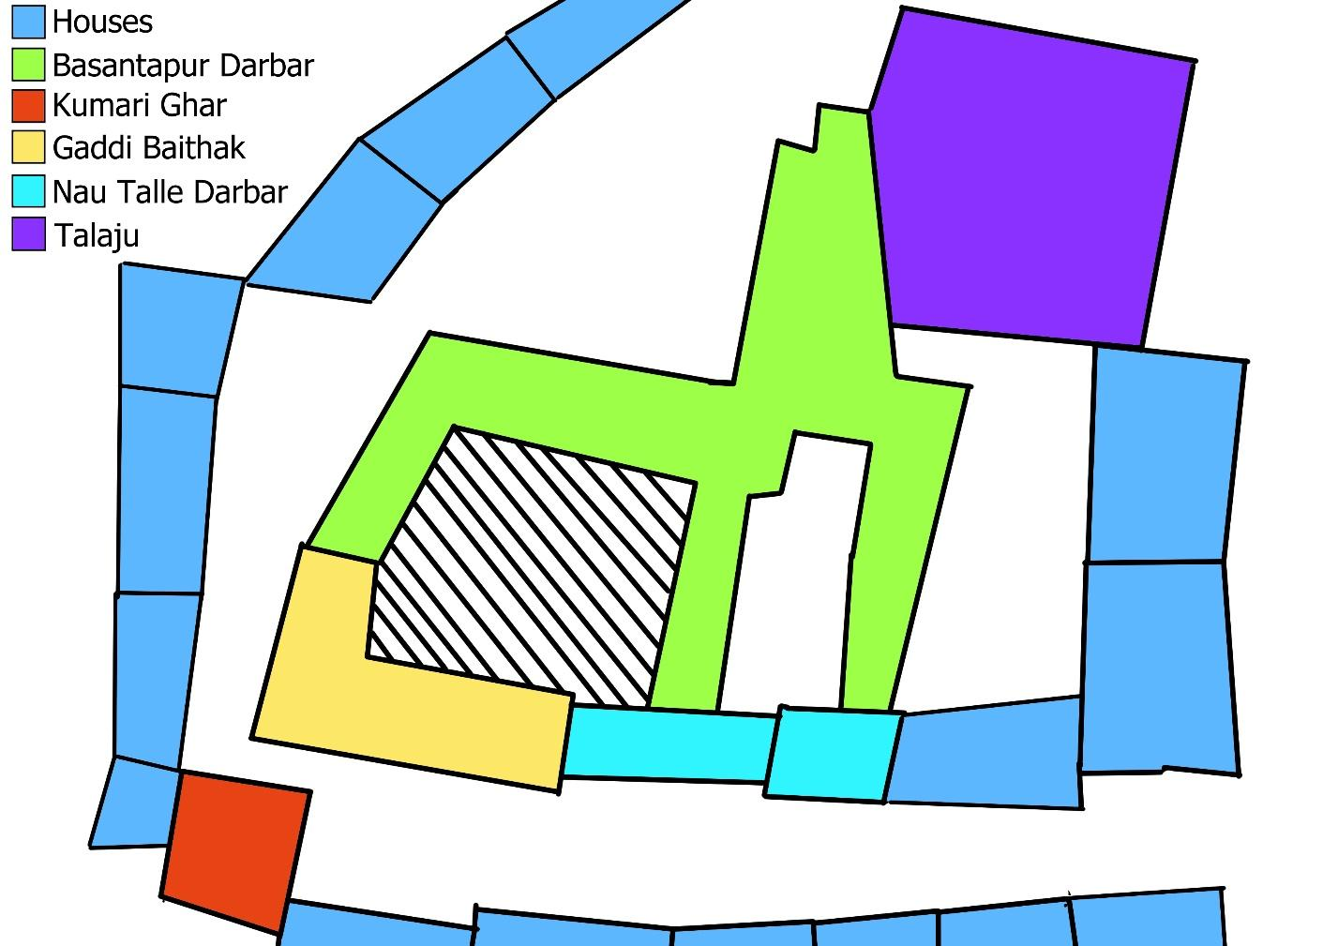

## Reference Image Links

* <https://transhimalayantour.com/userfiles/images/home.jpg>
* <https://thumbs.dreamstime.com/b/old-newari-house-old-newari-house-near-kathmandu-valley-108802409.jpg>
* <http://www.ravenouslegs.com/uploads/4/2/3/4/42340821/img-4671_orig.jpg>
* <https://upload.wikimedia.org/wikipedia/commons/thumb/6/68/Pashupatinaath0587.JPG/1200px-Pashupatinaath0587.JPG>
* <https://live.staticflickr.com/5819/21834791026_2af3a4a2aa_b.jpg>
* <https://english.onlinekhabar.com/wp-content/uploads/2018/09/newari-2.jpg>
* <https://upload.wikimedia.org/wikipedia/commons/thumb/8/81/Taleju_Temple_%2817231063613%29_%28cropped%29_%28cropped%29.jpg/1200px-Taleju_Temple_%2817231063613%29_%28cropped%29_%28cropped%29.jpg>
* <https://pbs.twimg.com/media/DxKmljgWwAEHuqN.jpg>
* <https://thehimalayantimes.com/uploads/imported_images/wp-content/uploads/2015/07/Taleju-Temple.jpg>